Name: Umair Ahmad Roll no: Su92-bsaim-F25-109
Class: BSAI-3B subject: Artifical intelligence (lab)
Instructor: Sir Rasikh Ali
Task 1:
Trace the supplied tree by hand using Minimax.
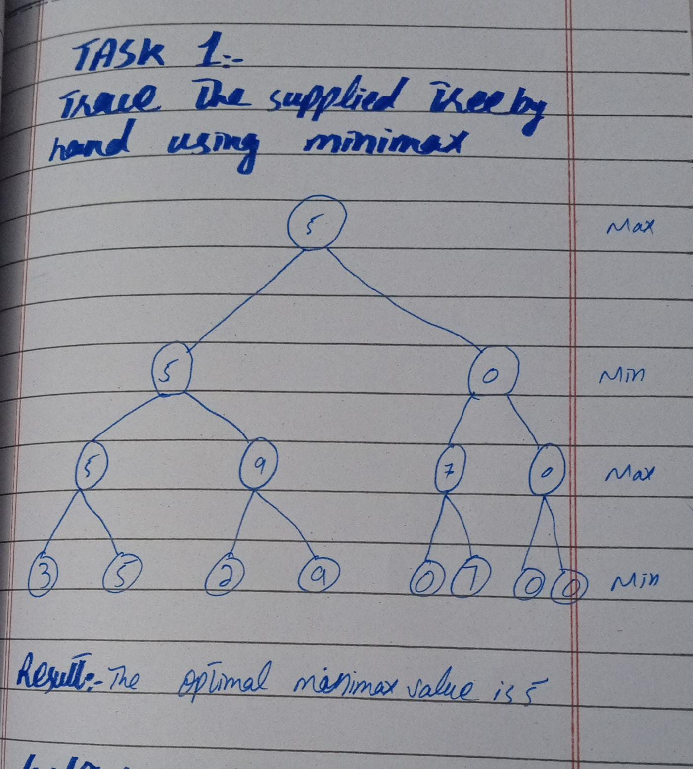

Level 2 (max):take pair of (3,5) (2,9) (0,7) (0,0) give 5,9,7,0.
Level 1 (min): take pair of (5,9) (7,0) give 5,0.
Level 0 (max):take pair of (5,0) give 5
Result: the optimal minima value is 5.

Task 2:
Add a leaf-evaluation counter to both algorithms
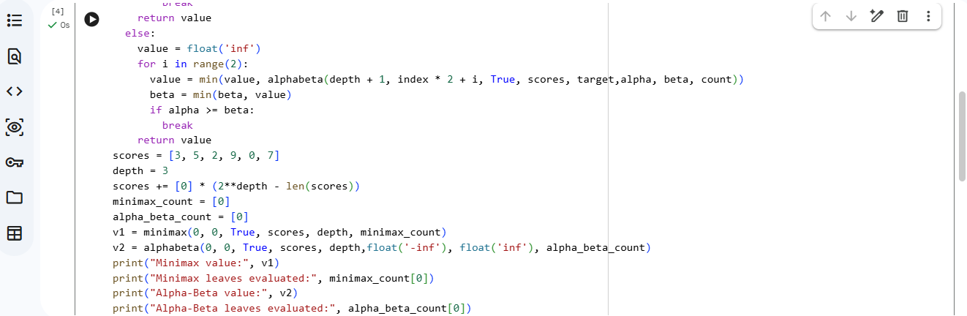
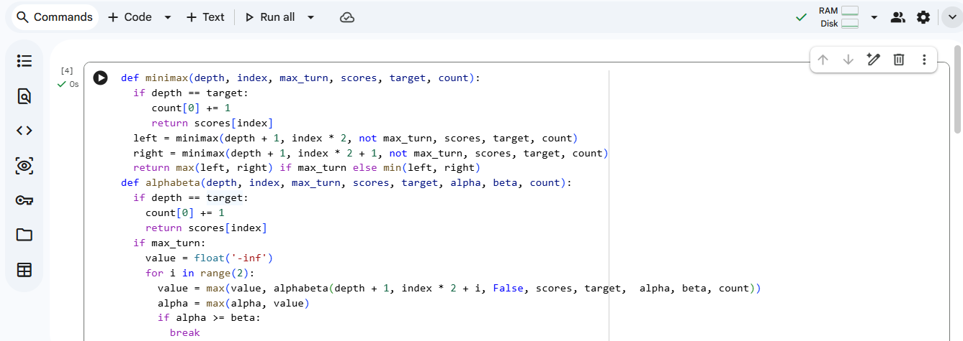
code:

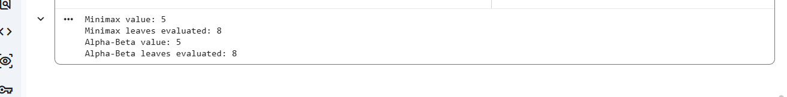
output:

Interpretation:
Both algorithms return the same root value. For this specific tree and left-to-right ordering, Alpha-Beta does not prune any leaves, so both evaluate eight leaves.

Task no 3:
Reorder branches and observe how pruning changes while the Minimax value remains the same.
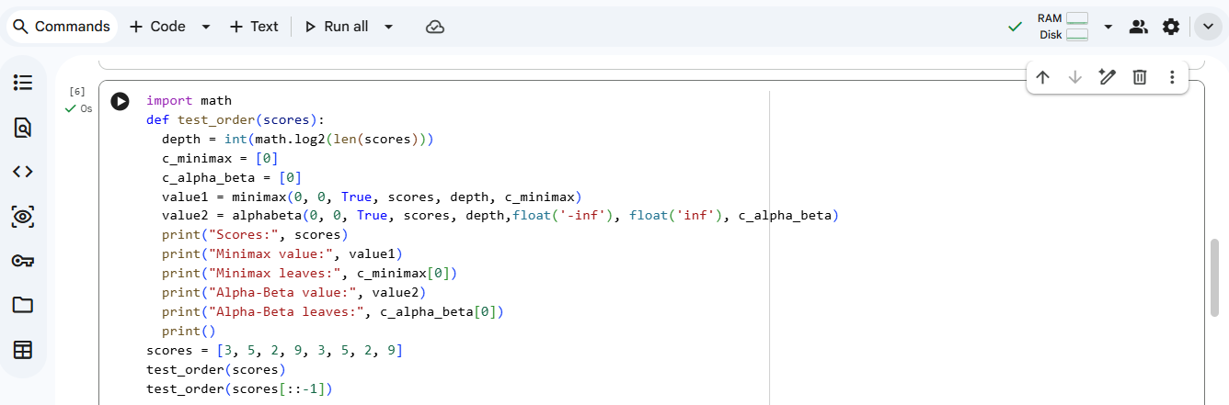
Code:

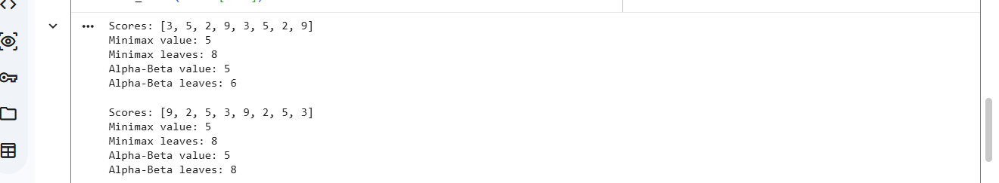
Output:

Comparison:
The root Minimax value remains 5 in both orders. In the original order, Alpha-Beta evaluates 6 leaves; in the reversed order, it evaluates 8. Thus, branch ordering affects pruning efficiency but not the optimal result.
Reflection:
In this lab, I learned how Minimax selects the best move in a two-player game. I added leaf-evaluation counters to compare Minimax and Alpha-Beta Pruning. The results showed that both algorithms return the same optimal value, while branch ordering can change the number of leaves evaluated. I will verify the output by running the program and include screenshots of my own execution.
Responsible:
Practice I checked the logic of the algorithms and will run the code to verify the results before submission. I will include genuine screenshots from my own run and explain any differences between my output and the expected output.

